HARROW COUNCIL
DIGITAL INFRASTRUCTURE STRATEGY
Contents
Introduction 2
National and Regional Policy Background 2
Harrow Council Aims and Objectives 3
Digital Infrastructure in Harrow 3
Targets 4
Harrow Council’s Approach to Providing Access 5
Fibre Broadband Investment 6
Telecoms (4G & 5G) Investment 7
5G Health and Safety 7
Digital Exclusion & Social Value 7
Smart City 8
Key Contact 9
Glossary 10
Appendix A Broadband Availability in Harrow 11
Appendix B Harrow Council Digital Strategy Aims 13
Appendix C WLA Digital Programme 2021 22 14
Appendix D Action Plan 2021/22 & 2022/23 16

Introduction
This is Harrow’s first Digital Infrastructure Strategy for encouraging and facilitating the deployment of full fibre broadband and 5G infrastructure in the borough.
It helps deliver Harrow’s Borough Plan objective that “Everyone has a quality, energy efficient and digitally-enabled home in a thriving community” and forms part of the Council’s wider Digital Strategy. It specifically addresses the Digital Community/Place aim within that Strategy (see Appendix B).
The development of digital infrastructure is also at the heart of the council’s Economic Strategy, as it supports the development and growth of the local economy as a whole and key sectors within it such as the knowledge economy.
The effect of the Covid 19 pandemic has highlighted the importance of good broadband connections as demand at home has increased due to a combination of increased working from home, home schooling and increased online shopping. Average data usage per household increased by more than a third from 315 Gb in 2019 (itself up from 241 GB in 2018) to 429 Gb in 2020 [Source: Ofcom - Connected Nations 2020 Report] and usage and the need for increased capacity is likely to increase over the coming years.
This Digital Infrastructure Strategy:
- Defines council policy in relation to digital infrastructure
- Outlines the current extent of “digital infrastructure” in the borough, identifying key issues and challenges
- Sets out how Harrow Council will facilitate the deployment of digital infrastructure

National and Regional Policy Background
The delivery of digital infrastructure is governed by the Digital Economy Act 2017 and the Electronic Communication Code (ECC). This legislation gives statutory rights to (qualifying) telecommunications operators to construct infrastructure and install and maintain equipment on, under and over land to provide communications network. Government legislation now allows broadband fibre investors and operators to apply for wayleaves to landlords to request access to their property to install the required infrastructure and that where this agreement is not given, the operators can ask for an agreement to be imposed by a court order.
The National Planning Policy Framework Planning (NPPF) also supports the expansion of electronic communications networks, including next generation mobile technology (such as 5G) and full fibre broadband connections. Planning policies are required to set out how high-quality digital infrastructure, providing access to services from a range of providers, is expected to be delivered and upgraded over time; and should prioritise full fibre connections to existing and new developments.
The Government has set a target that the whole country should have access to "gigabit-capable" infrastructure by 2025. It has pledged £5 billion of funding to roll out better broadband in the hardest-to-reach areas of England, Scotland, Wales and Northern Ireland which covers around 20% of the country, with a particular focus on rural areas. The government believes that the commercial sector should be providing the full fibre network in London.
In August 2020, the government sent a letter to councils to set out their views on how they can help in the delivery of digital infrastructure. The letter recognises that Councils are in an excellent position to support investment and roll out by ensuring that effective policies and procedures are in place to promote engagement with industry. Specifically, it recognises that the deployment of networks is complex and requires strong collaboration (i) between telecommunications operators, councils and third parties (such as contractors) and (ii) within the council (highways, planning, legal, estates and housing).
WLA Digital Programme
The West London Alliance (WLA), of which Harrow is a member, has developed a Digital Programme for the West London Area - see Appendix C. This focuses on broadband investment and 5G investment co-ordination across the boroughs to promote and facilitate Fibre to the Premises investment (Fibre West Programme) and 5G investment (Expanding Opportunities Programme), and promotion of west London as a digital hub for businesses and 5G investors.

Harrow Council Aims and Objectives
Harrow Council has a commitment to the delivery of digital infrastructure as stated in its “Borough Plan” and Digital Strategy.
Harrow’s Borough Plan objective is that “Everyone has a quality, energy efficient and digitally-enabled home in a thriving community” while the “Digital Community” Theme in the Digital Strategy and the Connecting Communities theme of the Economic Strategy includes objectives to create the conditions for economic growth and sustainable communities as a whole and key sectors within it such as the knowledge economy.
This includes improving access to digital technology in areas where it is most needed; stimulating an expansion of digital infrastructure across the Borough; taking advantage of the emerging “internet of things” to deliver smarter services; attracting and nurturing digital skills; and, making Harrow an attractive location for knowledge economy and digital and creative businesses.
To help achieve these objectives, this Digital Infrastructure Strategy supports a council approach whereby the council works with the private sector in line with the Digital Economy Act 2017 and the Electronic Communication Code to deliver the digital infrastructure within the borough, rather than rely on public sector funding.

Digital Infrastructure in Harrow
This section sets out the provision of digital infrastructure in the borough, as currently known. This includes broadband fibre, and mobile phone connectivity including 4G & 5G. It should however be noted that the information available on provision is limited due to a combination of the way the infrastructure is delivered (by various private sector companies) and the reluctance of those companies to share the information and plans. Ofcom does gather data annually from the operators for regulatory purposes and publishes very high-level findings as part of their annual Connected Nations report, the latest Connected Nations update was published in Summer 2021, with figures as of May 2021.

Broadband Infrastructure & Fibre to the Premises (FTTP)
The latest data available from Ofcom (for May 2021) shows that just over 15% of the borough has full fibre (FTTP) coverage (See table 1 below), compared to a London average of 27.6%.
Appendix A Fig 1 shows coverage of Full Fibre (Fibre to the Premises) in Harrow at a post code level as at September 2020 (Ofcom stopped publishing full fibre information at a post code level after 2020).The area identified to the south of the borough with good full fibre coverage corresponds to Openreach’s Kenton Fibre First project, while that to the north west corresponds to Openreach’s Hatch End Fibre First project. Fig 2 shows Unavailability and Not Spots in Harrow.

Table 1: Summary of Broadband Availability in Harrow
Speed | Harrow | London Average
Super Fast | 97.6% | 95.18%
Ultra Fast | 80.6% | 76.69%
Gigabit Capable | 15.4% | 27.08%
Source: Ofcom via GLA -as at May 2021

4G and 5G
The specific locations of small cells and detailed information about the type of equipment installed is not publicly available. Operators have current coverage maps available at their websites. See appendix A fig 3 for 4G & 5G EE coverage in Harrow.

Targets

KPI | Target &  Outcome | Harrow Actual | Comments/Issues
Gigabit capable coverage  Data from Ofcom via www.maps.london.gov.uk/connectivity | Target: To match London average over 3 Year period from May 2021 |  | Source: Ofcom – Annual Connected Nations Report.  Ofcom occasionally change the way the data is collected. Target/ outcome will have to be reviewed if this is the case.
May 2020 | London average:  18.2% | 12.3%
Sept 2020 | London average: 25.0% | 15.0%
May 2021 | London Average: 27.08% | 15.4%
% LBH Social Housing with access to Full Fibre Connectivity (1GB) | 100%  6800 units | No current available data | Wayleave framework agreement to be signed with providers.  Roll out scheduled over 3 years from when wayleave agreement signed.  100% target is ideal target, there will be some properties where FTTP connections are not possible for technical and other reasons.

Harrow Council’s Approach to Providing Access
In line with Government guidance, Harrow’s aim in all cases will be to enter into access agreements on an open access basis, which means exclusivity is not granted, and on terms which reflect government policy and the legislative framework. The Council will use framework agreements that set out the council’s requirements and are therefore consistent for all providers, rather than negotiate with individual providers.
It is assumed that most agreements will be with operators that have code rights under the Electronic Communications Code. For companies that request access to council land outside of the Electronic Communications Code, the Council will assess the proposals based on government policy and the legislative framework, including the council’s Planning policy as set out below.
Planning
The Council recognises that advanced, high quality and reliable communications infrastructure is essential for economic growth and social well-being. Its planning policies and decisions support the expansion of electronic communications networks, including next generation mobile technology (such as 5G) and full fibre broadband connections.
In assessing applications for communications infrastructure, the council will take account of the Government guidance as set out in the NPPF (Chapter 10), as well as its local plan policies.
Policy DM1 of the Harrow Development Management Policies Local Plan (2013) seeks to resist proposals detrimental to local character and appearance and have regard to the height of proposed buildings in relation to their location, surroundings and impact on neighbouring occupiers.
Policy DM49 seeks to ensure that the installation of new telecommunications equipment minimises its impact on the character and appearance of the area within which it is located.
Code Operators should make use of the Harrow Planning pre-application meeting service. Harrow Planning Department can be contacted through the Council web site – see https://www.harrow.gov.uk/planning-developments/planning-applications-advice-service
Further information on telecoms infrastructure will be provided in the Council’s Telecoms Toolkit.

Fibre Broadband Investment
There are several broadband infrastructure companies operating in London. In addition to Openreach and Virgin, new operators have come into the market in recent years including Community Fibre, G Network and Hyperoptic. These new operators have access to Government backed investment finance to help deliver the Government’s aims. Some of the operators have already approached the Council to request access to the Council’s housing stock. This will give the providers access to a number of potential subscribers and make investment in the fibre network financially worthwhile for them in the medium to long term.
Harrow Council signed a Framework Wayleave Agreement with Community Fibre in April 2021 and wish to sign further agreements with other providers.
Openreach has completed its “Fibre First” roll out in Kenton and is currently working on a “Fibre First” roll out in Hatch End.
New council led development, such as the regeneration of the Grange Farm estate and new housing to be provided through the Harrow Strategic Development Partnership with Wates, provides an opportunity to ensure residents of these developments benefit from the latest FTTP infrastructure.
As identified above, there is little public sector funding available for digital infrastructure investment (especially fibre broadband) in London. The Council will therefore need to work with the private sector to ensure the development of broadband infrastructure across the borough. As part of this approach, the council will seek to meet the following aims in the delivery. Where public sector funding does become available, the council will use this funding to address not spots and digital exclusion issues.
To maximise the extent and coverage of fibre broadband availability for residents and businesses in the borough: As part of this work, the council will seek to ensure that new investors do not “cherry pick” locations with maximum potential return and leave areas that are less commercially attractive with no FTTP connections. The council will require providers to set out their investment proposals so that these potential residential and commercial “not spots” can be identified early in the investment process and ways to overcome these issues sought with the providers. The Council will work with the providers to ensure that town centres (district and local centres) and Harrow Metropolitan centre, as well as industrial areas are wherever possible included in any roll out.
To deliver the rollout of improved digital infrastructure in a way that minimises the disturbance to residents and businesses in the borough :The Council will require that the providers work closely with both the council’s Housing team and Network Management team to provide information on their proposed investment plans that allows coordination of works and minimises disruption in the borough.
To leverage social, environmental and economic value and secure investment in digital investment that everyone in the borough can benefit from: The council will work with the providers to ensure that the digital inclusion and social value aims set out below are met through any investment.
Wayleave Agreements & Access to Council-owned housing
The Council has worked with LB Barnet and LB Hounslow through its shared legal service (HB Public Law) to develop a Wayleave Framework Agreement for fibre providers, the aim of which is to address some of the issues highlighted in this Strategy.
The Framework Agreement includes the overarching programme, standards, compliance and commercial terms for each suitable service provider. The site specific technical, safety and communication matters are then addressed through a ‘signing off’ process that completes the wayleave for each relevant block.
As at December 2021, Harrow Council has signed a Wayleave Framework Agreement with Community Fibre and is keen to agree further agreements with other providers.

Telecoms (4G & 5G) Investment
The Council will work with telecoms providers and their agents to allow access to Council assets, based on a non-exclusive, open access approach as recommended by Government guidance.
The Council will produce a Telecoms Toolkit that provides
● Guidance to Code Operators seeking to host 4G/5G Small Cells on Council assets;
● Guidance on setting up an agreement between the Local Authority and the Code Operator;
● Standard Financial Terms; and
● Advice on the processes for Code operators to follow when considering siting digital communications infrastructure on Council assets.

5G Health and Safety
(from 5G mobile technology: a guide Ofcom Published 27 August 2020)
Harrow Council follows the advice and guidelines set by national Government via Public Health England (PHE) regarding health and safety issues related to 5G.
PHE endorses the international guidelines for limiting exposure to radio waves, published by the International Commission for Non-Ionising Radiation Protection (ICNIRP). These guidelines cover many uses of radio frequencies, including Wi-Fi, Bluetooth and mobile technologies. The guidelines were updated in March 2020 and take full account of 5G operating at higher frequencies.
In relation to 5G, PHE have said that “the overall exposure is expected to remain low relative to guidelines and, as such, there should be no consequences for public health”.
Mobile companies are also required to ensure that their signals do not exceed the limits set out in the ICNIRP guidelines for the protection of the general public. Planning law and policy requires that planning applications for electronic communications development should be accompanied by a statement or declaration that certifies that when operational, equipment will be compliant with the ICNIRP guidelines for limiting exposure to electromagnetic fields

Digital Exclusion & Social Value
Research undertaken in 2019 suggested that the most common reason for not having internet access in the household is a perceived lack of need (over 60%), followed by a lack of skills. This is particularly the case among certain groups, including older people and disabled people as well as potentially those not living in private households. It should be noted that under 10% of households see costs of equipment or subscription costs as being too high, while a number of households access the internet elsewhere.
The research concluded that these barriers to digital inclusion suggest part of the education for digital skills may need to start by highlighting the benefits of being online and overcoming any apprehension to engagement.
The effect of the Covid 19 pandemic since the research was undertaken has highlighted the importance of good broadband connections, meaning that those without the skills and connections are even more likely to be excluded from accessing employment and services.
Given this analysis, it is proposed that the Council focus on the following that relate to digital infrastructure to help address digital exclusion:
- Providing training to the “digitally excluded” on how to use the internet in conjunction with the Council’s Adult Community Learning service (Learn Harrow)
- Providing access to the internet at no or low cost to residents either at home or at community buildings such as libraries and community centres to ensure access to those unable to afford internet / wifi provision
The Council will therefore work with providers to provide the following.
- Free Connections – The provision of free Gigabit Internet connections to community facilities that are within reach of its network footprint.
- Digital Engagement – The provision of digital engagement training for members of the communities where it introduces its services.
Employment Opportunities – This new investment will provide new employment opportunities in an identified growth sector. The network builder must work with the Council’s Xcite employment service, with the aim of maximising employment and apprenticeship opportunities for local residents.
The council will include these requirements as part of any agreements signed between the council and telecoms providers. If a provider is not able to provide directly, the council and provider will work together to identify other social value provision to an equivalent value.

Smart City
The concept of Smart Cities has increased its profile over the last few years, although exact definitions and understanding do vary depending on the viewpoint of the user. In simple terms, smart cities “use new technologies (mainly information and communication technologies) and data to improve service delivery and address various economic, social and environmental challenges”.
The use of the Smart City technology is linked to digital infrastructure in that the infrastructure (usually 5G and Broadband Fibre) needs to be in place to fully utilise the benefits of smart city technology.
“Smart City” Links to Council Service Delivery
Harrow Council is at an early stage of assessing how it can make the best use of this emerging technology. As well as allowing residents better access to council services, this technology can help deliver services including for example traffic management, empowering social care processes, real time information to address the climate change emergency and NHS emergency diagnoses.
Austerity and the Covid 19 pandemic has forced the council to focus on delivering key services rather than looking to the future. This and the fact that many of the smart technologies are at an early stage of development make it difficult for the council to assess the business case of investing in the technology.
Work on Smart Cities and service delivery is developing through the West London Alliance’s (WLA) Digital programme, and with support from the London Office of Technology and Innovation (LOTI), and the GLA’s Smart London Team & Sharing Cities programme. The Council will work with these organisations and others to identify how these new technologies can help improve and deliver council services, while ensuring that they offer value for money for residents.

Key Contact

Harrow Digital Infrastructure Coordinator
Name David Sklair
Email: David.Sklair@Harrow.gov.uk

Glossary

FTTC - Fibre to the Cabinet: In an FTTC network, fibre is installed from the carrier network to the distribution point. This is why FTTC is known as fibre to the cabinet (the street level cabinet or distribution point). The FTTC product uses high-speed fibre to the cabinet but then uses copper to reach the business.
The use of copper in the "last mile" significantly reduces the bandwidth speed that can be achieved over the FTTC service. The data signal degrades over copper, so the longer the copper wire from the cabinet to the business premises, the slower the speed a business will get from the FTTC service.
Full Fibre/Fibre to the Premises (FTTP): Unlike FTTC, FTTP connects the last part of the network, between the distribution point and the business premises by fibre. Replacing the copper in the "last mile" with fibre has the effect of removing the bandwidth bottleneck that traditionally copper networks have caused and allowing for much greater amounts of data to be transferred.
Super Fast: Superfast broadband describes any broadband service that provides speeds of 30Mbps or higher
Ultra Fast: Ultrafast broadband describes any broadband service that provides speeds of between 100Mb per second and 1Gb (1000 Mb)
Full Fibre: This allow for offer much faster average speeds of one gigabit per second (Gbps) (= 1,000Mbps). It could potentially offer speeds in terabits per second in the future. (One terabit equals 1,000 gigabits.)
4G: 4G (LTE) (Long Term Evolution) was a major enhancement to mobile radio communications networks. 4G (LTE) is a standard that is part of the evolution of 3G, which incorporates significantly increased data rates (up to 100Mb/s) and better performance to enhance the mobile broadband experience.
4G (LTE), like all other radio communications standards, is based on the use of radio waves or radio frequency (RF) energy to transmit and receive voice and data calls.
5G: 5G is the 5th generation of mobile networks, a significant evolution of today’s 4G networks. 5G is being designed to meet the very large growth in data and connectivity of today’s modern society, the internet of things with billions of connected devices, and tomorrow’s innovations.
5G networks are designed to work in conjunction with 4G networks using a range of macro cells, small cells and dedicated in-building systems. Small cells are mini base stations designed for very localised coverage typically from 10 metres to a few hundred metres providing in-fill for a larger macro network. Small cells are essential for the 5G networks as the mmWave frequencies have a very short connection range.
5G wireless devices in a cell communicate by radio waves with a local antenna array and low power automated transceiver (transmitter and receiver) in the cell, over frequency channels assigned by the transceiver from a common pool of frequencies, which are reused in geographically separated cells. The local antennas are connected with the telephone network and the Internet by a high bandwidth optical fibre or wireless backhaul connection.

Appendix A Broadband Availability in Harrow
Source GLA/Ofcom via maps.london.gov.uk/connectivity

Fig 1. Full Fibre Availability In Harrow September 2020
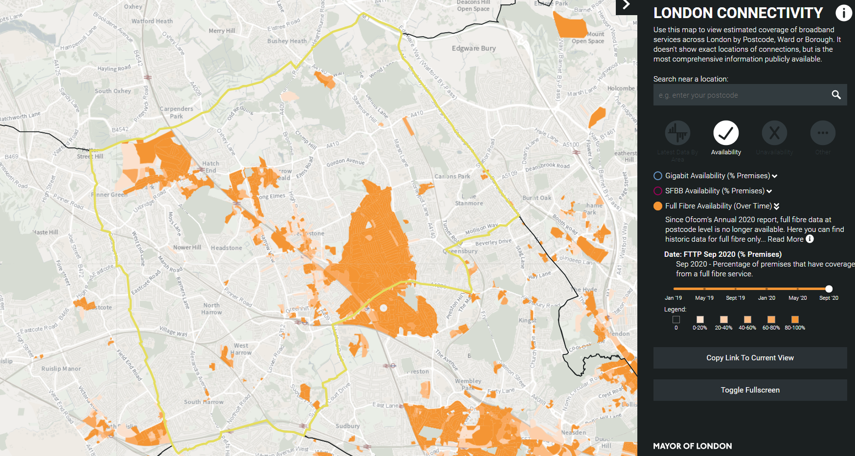

Fig 2: Unavailability and Not Spots in Harrow
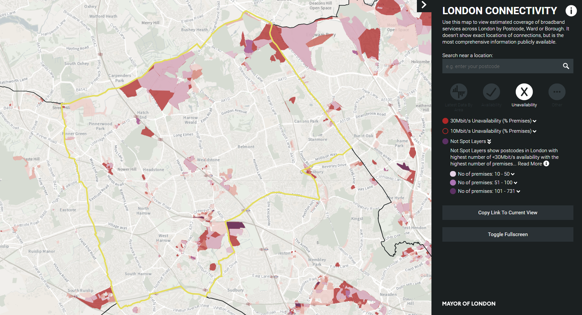

Fig 3: 5G & 4G availability in Harrow via EE network – November 2021
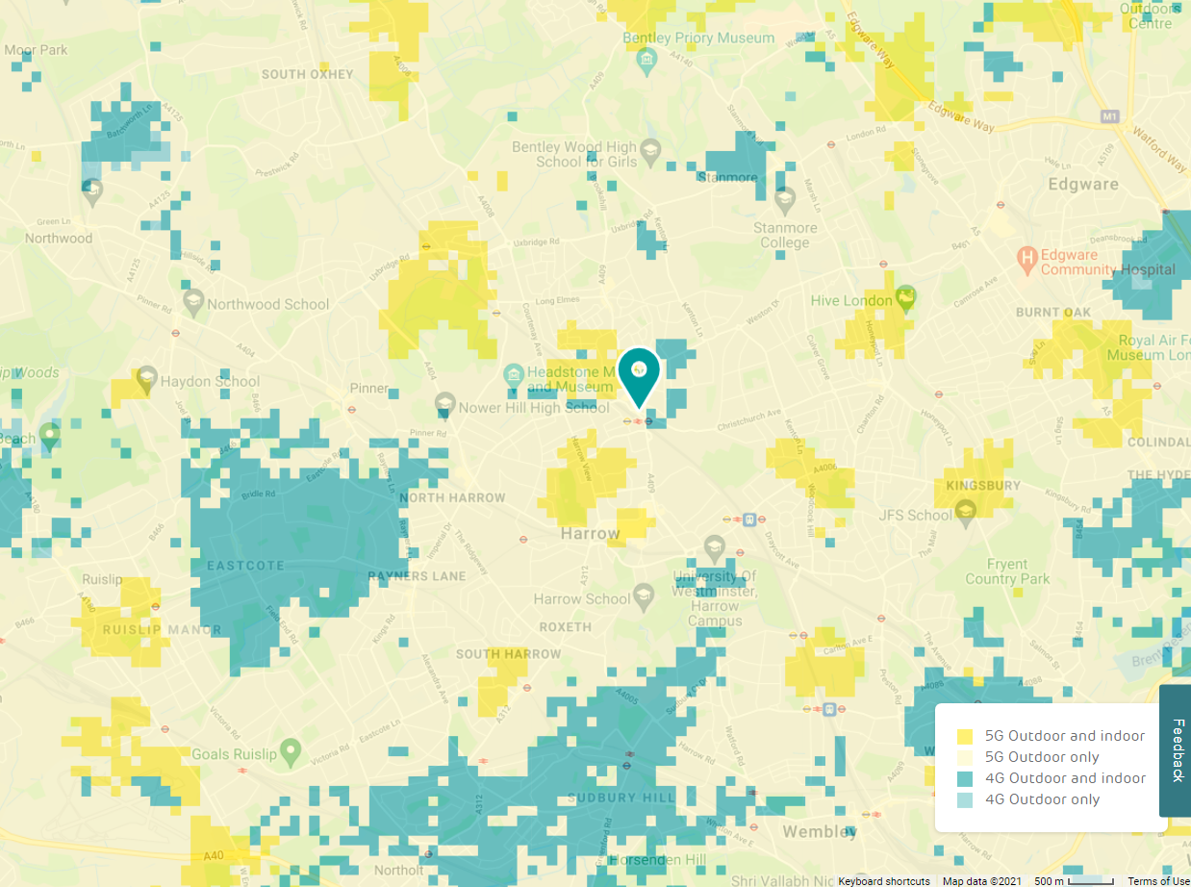

Appendix B Harrow Council Digital Strategy Aims
Digital Community/ Place Creating the conditions for economic growth and sustainable communities: by improving access to digital technology in areas where it is most needed; stimulating an expansion of digital infrastructure across the Borough; taking advantage of the emerging “internet of things” to deliver smarter services; attracting and nurturing digital skills; and, making Harrow an attractive location for digital and creative businesses
Digital Customer/People Building online services around citizens and businesses: by redeveloping our website and My Harrow account to provide a single and efficient point of access to council services; maximising digital channels, including social media, to revitalise democracy and engage hard to reach groups; and, nurturing digital skills in the community so our most vulnerable residents are not left behind
Digital Council Enabling the delivery of value for money services through flexible and secure technology: through transforming the Council’s workforce so it is digital and mobile by default; using technology to integrate services across organisational boundaries; taking advantage of the cloud to update and optimise our internal systems; and, providing open access to real time and transparent information for the benefit of citizens and businesses

Appendix C WLA Digital Programme 2021 22
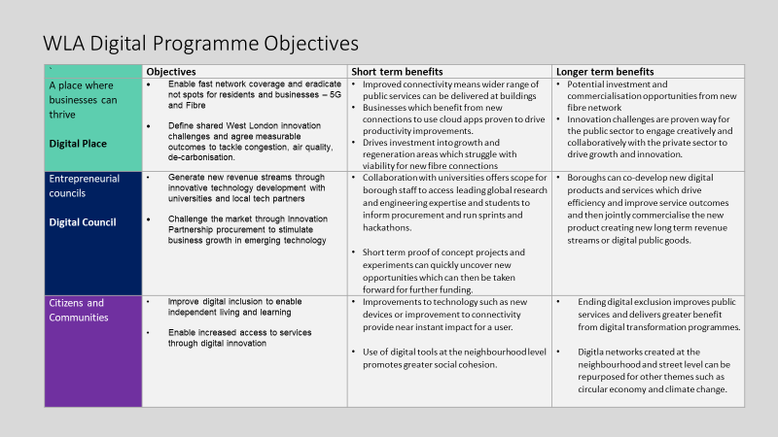
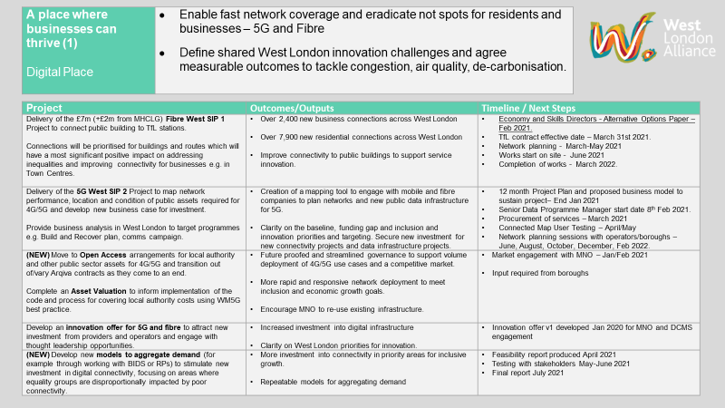
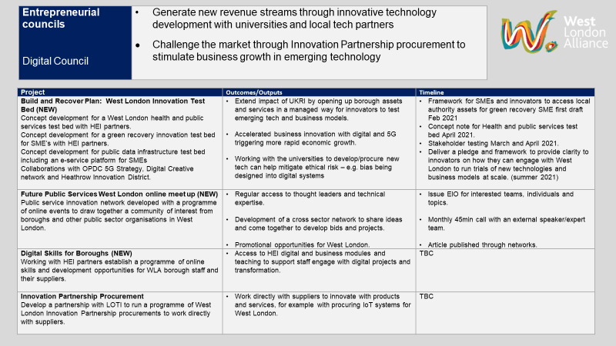
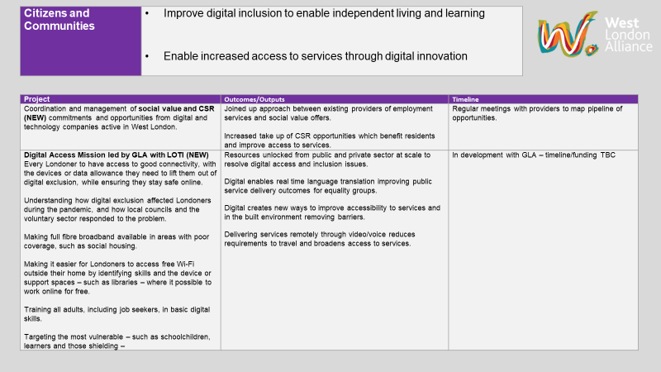

Appendix D Action Plan 2021/22 & 2022/23
Digital Strategy Aim | Action | Lead | Budget | Timescale
Stimulating an expansion of digital infrastructure across the Borough
Strategic actions | Work with WLA and relevant council officers to help deliver the WLA Digital programme. | Digital Infrastructure & Smart City Lead /Harrow Digital Project Team | Officer time | Q4 2021/22  Q 1- 4 2022/23
 | Work with WLA/GLA/DCMS to maintain knowledge on digital infrastructure related policy, issues and funding. | Digital Infrastructure & Smart City Lead | Officer time | Q4 2021/22  Q1- 4 2022/23
 | Work with industry to promote to the local authority, residents and businesses the social and economic benefits of improved connectivity in the area/region. | Digital Infrastructure & Smart City Lead | Officer time/SIP Enabling Fund | Q4 2021/22  Q1- 4 2022/23
 | Work with WLA to compile a register of public sector assets and infrastructure, which can be used to host digital equipment. | Digital Infrastructure & Smart City Lead | Officer time | Q4 2021/22
FTTP Broadband Investment | Promote and agree social housing Framework Wayleave Agreement with fibre providers | Digital Infrastructure & Smart City Lead /Harrow Council - Housing Assets | Officer time | Q4 2021/22  Q1- 4 2022/23
 | Work with Harrow Assets team and providers to support roll out of FTTP broadband to social housing, ensuring digital infrastructure objectives and social value commitments are met | Harrow Council - Housing Assets/Fibre providers | Officer time/SIP Enabling Fund/Fibre provider contributions | Q4 2021/22  Q1- 4 2022/23
5G Investment | Work with WLA to develop 4G/5G “small cell” roll out strategy for west London | WLA/ Digital Infrastructure & Smart City Lead | Officer time | Q3 - Q4 2021/22
 | Develop a Telecomms Toolkit to provide guidance to providers and support the roll out of small cells in the borough | Digital Infrastructure & Smart City Lead /Harrow Digital Project Team | Officer time | Q4 2021/22
 | Promote and agree WLA small cell agreement with MNOs and neutral host providers | Digital Infrastructure & Smart City Lead | Officer time | Q4 2021/22  Q1- 4 2022/23
Improving access to digital technology in areas where it is most needed
Fibre Broadband Investment | Work with providers to ensure that there are no “not spots” as part of the fibre broadband roll out across the borough | Digital Infrastructure & Smart City Lead | Officer time | ongoing
Provide public access to broadband at public buildings | Secure fibre broadband connections to community centres, libraries and other public buildings  - via social value commitments from fibre providers  - via the WLA’s Fibre West programme | Digital Infrastructure & Smart City Lead | Fibre providers  WLA Fibre West funding  Officer time | Q4 2021/22  Q1 - 4 2022/23
Taking advantage of the emerging “internet of things” to deliver smarter services;
Maintain overview of developing services and offers | Work with the Digital Project Team to identify how new technologies can help improve and deliver council services, while ensuring that they offer value for money for residents. | Digital Infrastructure & Smart City Lead /Harrow Digital Project Team | Officer time | Q4 2021/22  Q1 - 4 2022/23
Attracting and nurturing digital skills
Support training and access to new digital employment opportunities | Work with Learn Harrow and the fibre providers to provide training and other support through the wayleave framework agreement  Work with the council’s Xcite team and the fibre providers to provide employment opportunities through the wayleave framework agreement | Harrow Council - Xcite Team | Officer time | Q4 2021/22  Q1 - 4 2022/23
Making Harrow an attractive location for digital and creative businesses
Attracting businesses to commercial space developed on regeneration sites and empty commercial premises | Ensuring FTTP broadband infrastructure is included in council regeneration/HSDP sites | Digital Infrastructure & Smart City Lead | Officer time | Q4 2021/22  Q1 - 4 2022/23

Digital infrastructure refers to all the hardware and software that is required for digital services to function in the borough. This includes broadband fibre, mobile phone hardware including 4G & 5G.
Gigabit capable coverage was introduced in the Connected Nations 2020 report, which includes all Full Fibre coverage, and all Coaxial coverage using Docsis 3.1 that has been identified as delivering download speeds up to 1 Gbit/s. However, due to commercial confidentiality, Full Fibre coverage has now been removed.
Providing access to Local Authority land, buildings and other assets for Digital Deployment DCMS/MHCLG August 2020 Annex B
Exploring the UK’s Digital Divide Office for National Statistics 4 March 2019
Social innovations in Context of Smart City p387 Richard Jurenka, Dagmar Caganova, Natalia Hornakova, Augustin Starecek in Smart Technology Trends in Industrial and Business Management EAI Springer 2019

